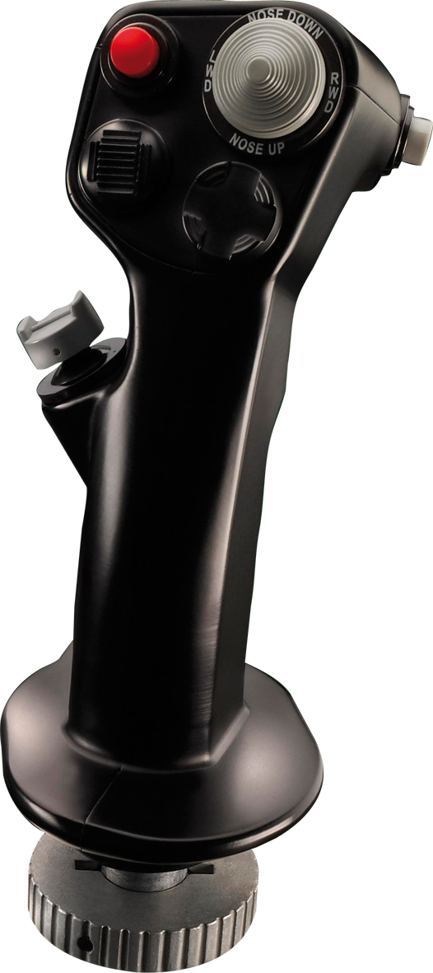
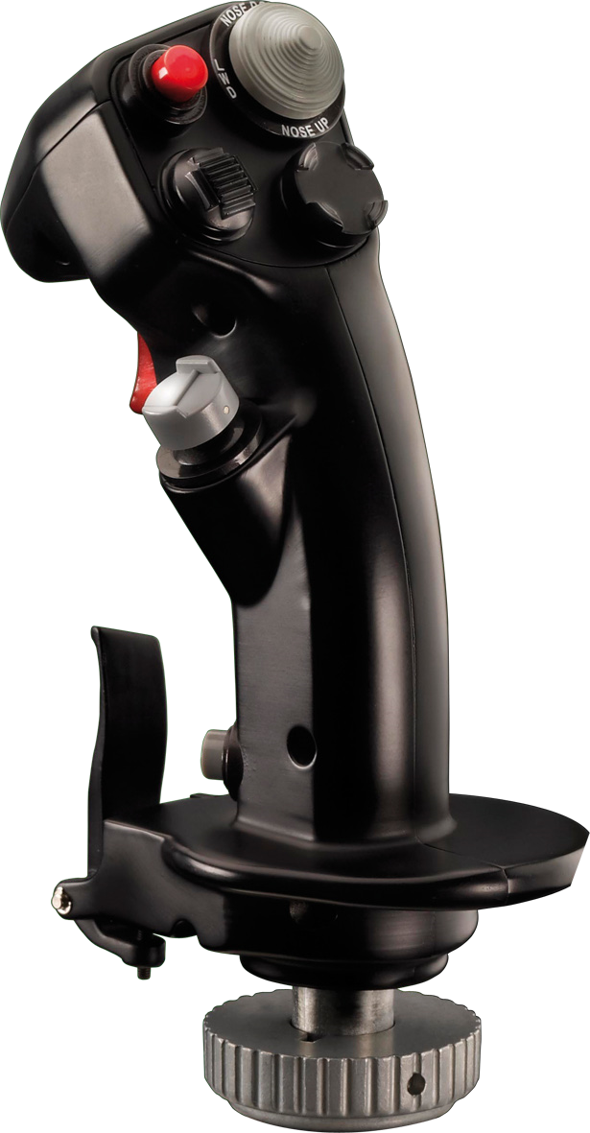
––
TMS
)
Target Management Switch
(
Up DX 7
Down DX 9
Left DX 10
Right DX 8
H2U
H2D
H2L
H2R
CMS (Countermeasures
Management Switch)
+
Push DX 19
Up DX 15
Down DX 17
Left DX 18
Right DX 16
H4P
H4U
H4D
H4L
H4R
Weapons
Release Button
S2 Secondary Fire
Trim Switch
DX Hat 1
H1U
H1D
H1L
H1R
DMS
Data Management Switch
Up DX 11
Down DX 13
Left DX 14
Right DX 12
H3U
H3D
H3L
H3R
Master Mode
Control Button
S1 DX 5
Gun Trigger
Stage 1
TG1 Prim Fire
Nosewheel
Steering Button
S3 DX 3
Gun Trigger
n/a
Paddle Switch
S4 dx4

